Subject:
Digital Signal and Image Processing (01CT1513)
Program/ Branch/Semester: | B.Tech/ ICT/ 5th Semester

Assignment 0
Due date : 12/8/2023

Sr. No. | Question
1 | Find out the Z transform and ROC of the following function.  - {1,2,1,2,3} (b) (n+1)²u(n) (c) log n (d) 2^{n}u(n)-0.5^{n}u(-n-1) (e) u(-n-6) (f) ẟ(n+5)  Also state about stability and causality of each function
2 | Find out the inverse Z transform of the following H(z) if the system is causal  - 1+z+z⁻¹ (b) log (1+z⁻¹) (c) (d) (e)
3 | LCCD equation of LTI System is as following:  y(n)=y(n-1)+5x(n)+2x(n-1)  Find out the impulse response, frequency response, magnitude response and phase response of system. If input is 2^{n}u(n), what will be output.
4 | If transfer function of LTI system is . Find out relationship between input and output. Also find out unit step response of following system.
5 | Find out convolution of 2^{n}u(n) and 5^{n}u(-n-1) using z transform.
6 | Find DTFT of following sequences  - (n+1)a^{n}u(n) (b) sin (wn) /πn (c) cos(wn+β) (d)e^{jwn}u(n) (e) x(n)=1 for –M<n<M
7 | Determine IDTFT of following sequence  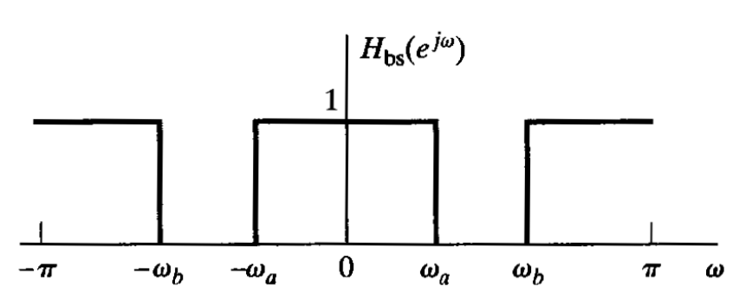
8 | Find out linear and circular convolution of following sequences  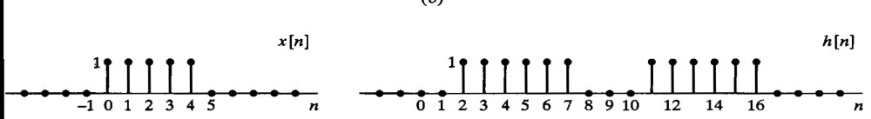
9 | Consider an LTI system with |H(e^{jw})|=1 and arg|H(e^{jw})| is shown in figure. Find impulse response of the system.  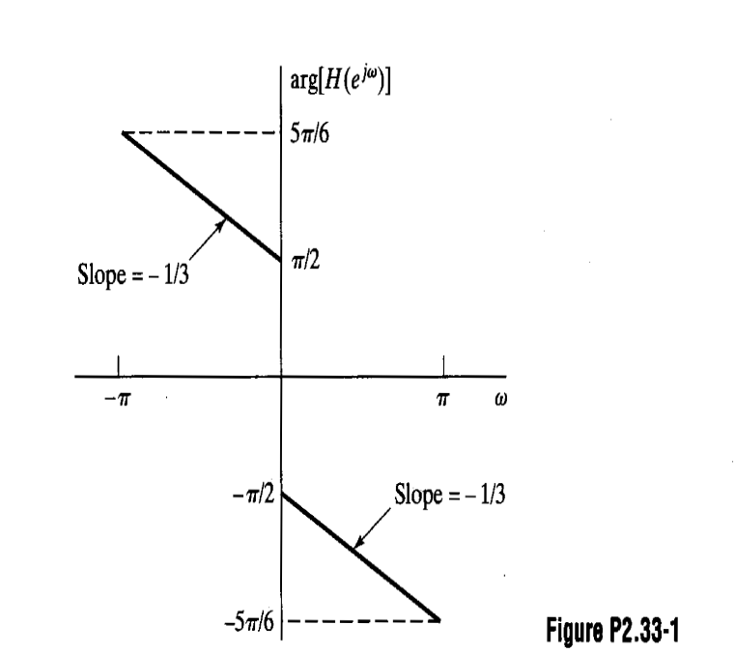  If input is cos(πn) u(n), what will be output. Also find unit step response of the system.
10 | Prove the following properties of Z transform.  (1) Differentiation of X(z) (2) Time Shifting (3) Convolution of sequences (4) Time Reversal
11 | State and prove symmetry property of DTFT.
12 | x(n)={1,1,2,2}; h(n)={1,2,3,4}  - Find linear convolution using circular convolution  - Find circular convolution using linear convolution  - Find linear convolution using DFT and IDFT  - Find Circular convolution using DFT and IDFT
13 | Find 8 point DFT of x(n)=cos(nπ/4). Then find amplitude and phase spectra.
14 | For each of the following system, determine whether the system is (1) stable (2) Causal (3) Linear (4) Time Invariant (5) memoryless  (i) y(n)= x[n-n0] (ii) y(n) = x[-n] (iii) y(n) = x²(n) (iv) y(n)=log (x(n)) (v) y(t)=dx(t)/dt
15 | Draw following signal x(n)=u(n)+3*delta(n-1)+4u(-n-3)  Also draw x(n-1), x(2n), x(n/2), x2(n) and x(-n)
16 | Find out whether signal is periodic/aperiodic. Find the period of following signals:  x(n) = exp(jπn/6), x(n)=sin(3n), x(n)=exp(jn/1.41), x(n)=sin 3πn + cos 6πn  x(n)=sin (πn) /πn

